Create a container in your storage account

Basics

Go to resource group

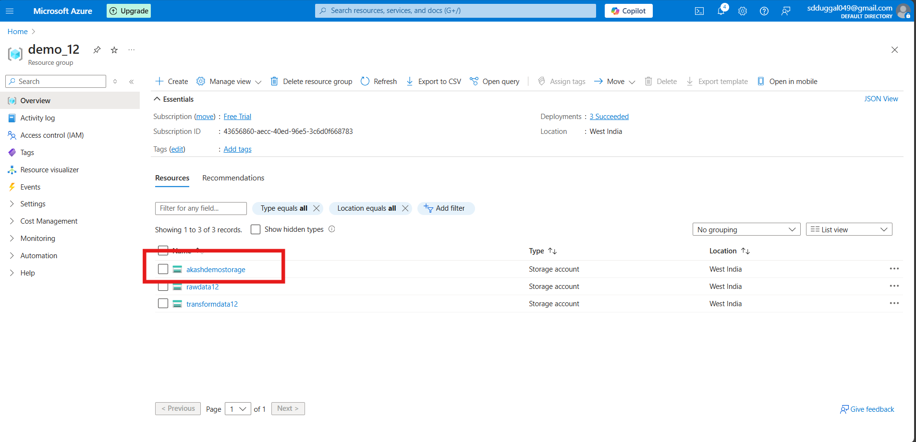

Click on the storage account you are using

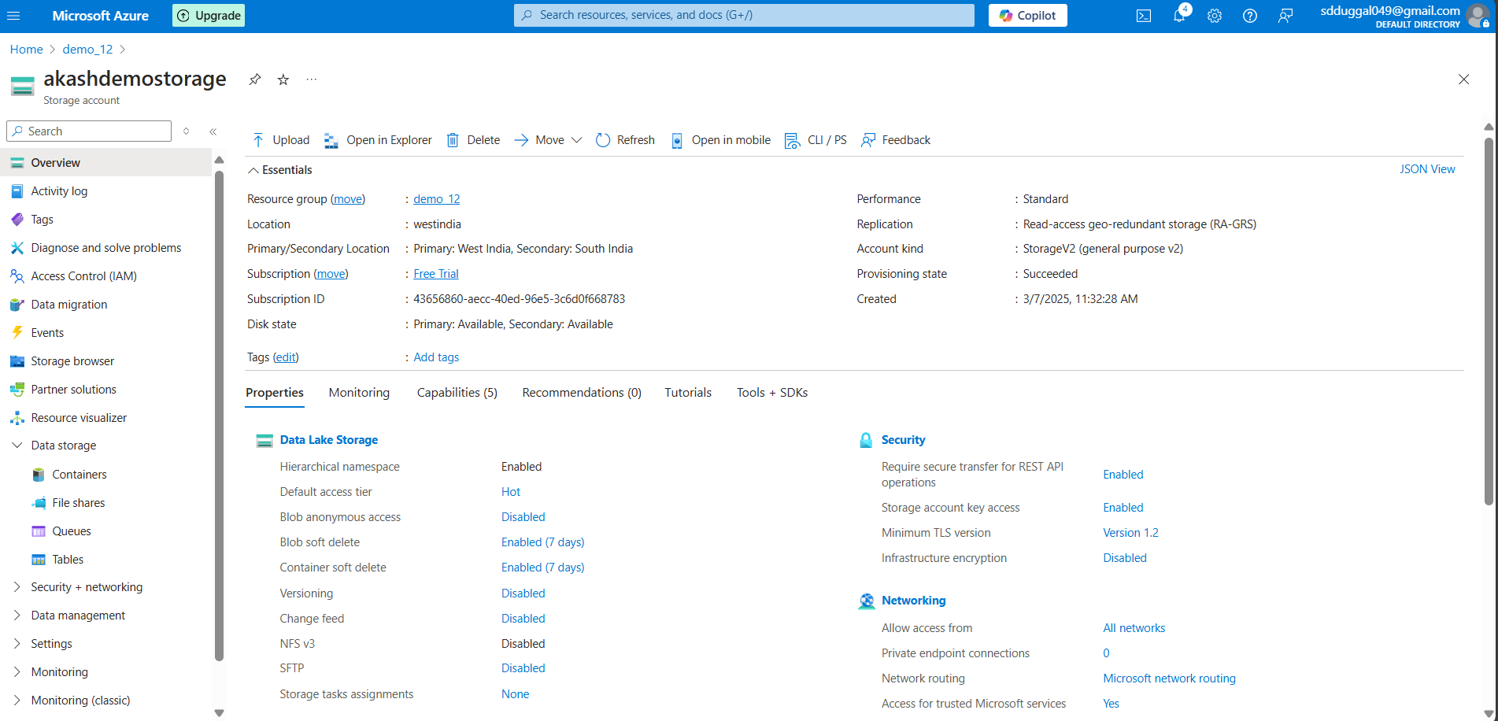

Create a Container named  
demo

Click on the container button

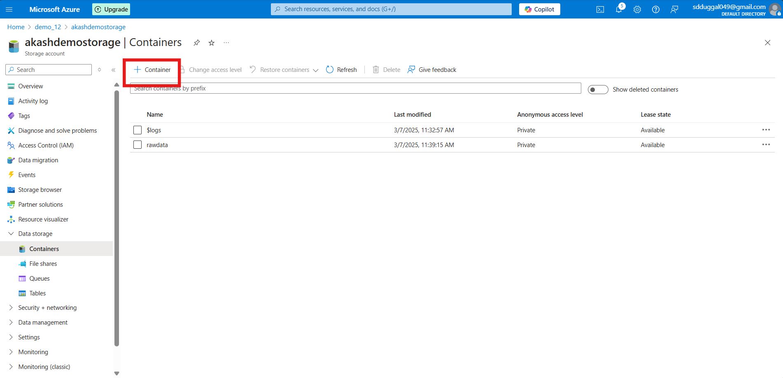

Create a container name demo

Click on create

Once its created you will get this screen

Inside that container

We have to create 2 folders

rawdata

transformdata

click on the container

Now we are inside the container

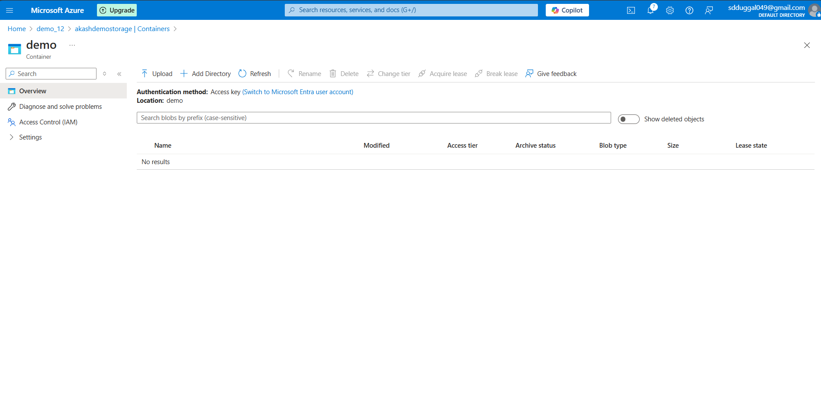

Click on the add directory button

Create a folder named rawdata and transformdata

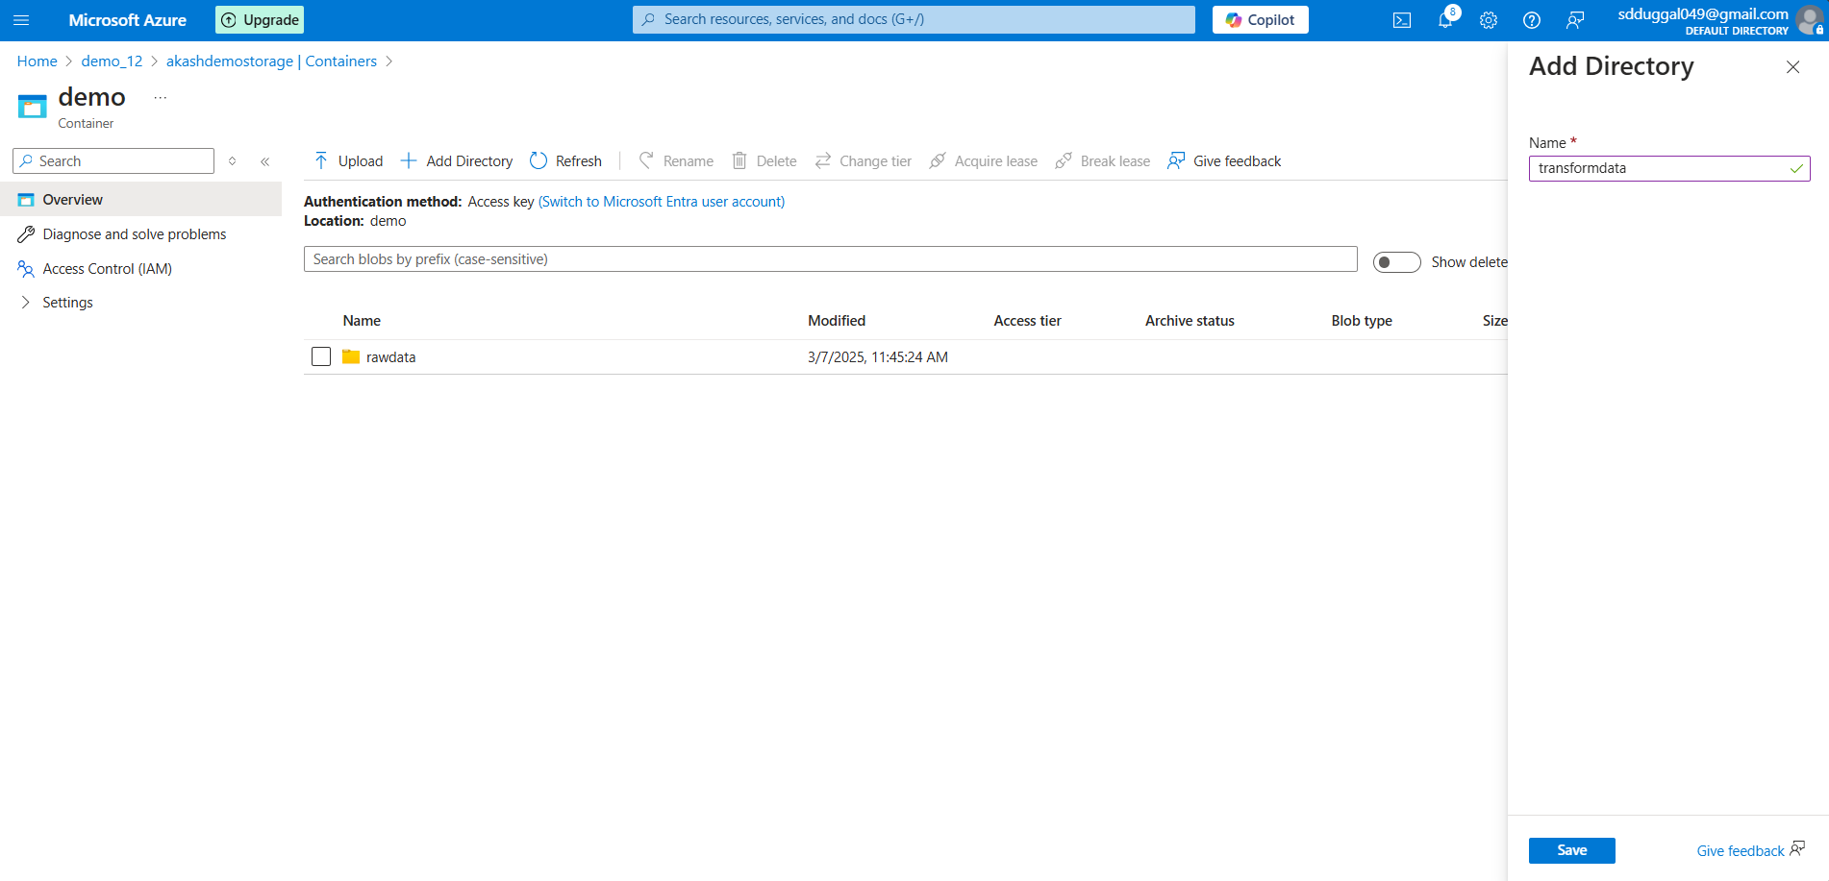

Once its create you are able to see this in the container

Cool

Till now

We have created the storage account and inside that we have created the container which have two folders’ names

rawdata and transformdata